

**NAANMUDHALVAN**

**DIGITAL MARKETING**

**PARK COLLEGE OF ENGINEERING AND TECHNOLOGY**

**KANIYUR COIMBATORE -641659**

**PROJECT REPORT**

# REELS DESIGN USING CANVA

TEAM MEMBERS

M.Mohamed Siddiq 712220106016

M.Azhagu Sumathi 712220106004

S.Dhayananth 712220106007

A.Barath Kishore 712220106006

**NAAN MUDHALVAN TEAM ID: NM2023TMID08352**

INTERNAL INCHARGE HEAD OF DEPARMENT

## CREATE A REEL USING CANVA

1. INTRODUCTION
   1. OVER VIEW
   2. PURPOSE
2. PROBLEM DEFINITIONAND DESIGN THINKING
   1. EMPATHYMAP

### 2. IDEATIONAND BRAINSTORMINGMAP

1. RESULT
2. ADVANTAGESAND DISADVANTAGES
3. APPLICATION
4. CONCLUSION

## 1.INTRODUCTION

1. **OVERVIEW**

To create a Reel design using Canva, start by signing in or creating an

account on Canva's website. Once logged in, click "Create a design" and set custom dimensions (typically 1080x1920 pixels for Instagram Reels). Design your Reel cover using Canva's templates, background options, text styles, and graphics. You can also upload images or videos. Customize elements by adjusting their size, position, and style. Arrange layers to your liking. After completing your design, click "Download" to save it to your computer. To use it on Instagram, upload it as the cover when creating or editing your Reel. Keep in mind that Canva's features and interface may have changed since my last update, so explore the platform for the latest tools and resources.

1. **PURPOSE**

They're perfect for vlogging, announcing sales, introducing a new product

line, or just sharing the beauty of your day-to-day experiences. So make the most Instagram Reels—create beautiful, share-worthy reels using Canva's awesome Instagram reel maker. Creating Reels in Canva video editor. Canva's video editor makes it easy to create Instagram Reels. Here's how to customize a Reel template to make you very own Reel using photos from your Instagram feed. In the Canva editor, search for 'Reels' and click on 'Instagram Reels'.

### 2.PROBLEM DEFINITION & DESIGN THINKING

**2.1Empathy map**

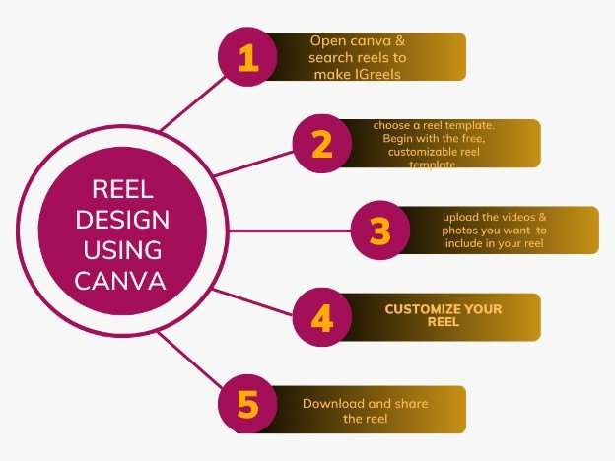

#### 2.2 IDEATION AND BRAINSTORMING MAP

**2.2.1 IDEATION OF THE PROFECT:**

* Start with a free canva account and search for create a reel on the home page.
* Select a reel template from the available options and open it.
* Customize your site by changing the text,photos,colors,fonts,and logos.You can also add content from canva libraries by clicking the different tabs on the editor side panel.
* Publish your desing as a reel by clicking the publish button.
* To create a link in github,you need to navigate the main page of the repository • Choose whether to select a single line .
* Navigate to the conversation where you want to link to the code.

##### 2.2.2.BRAINSTORMING MAP

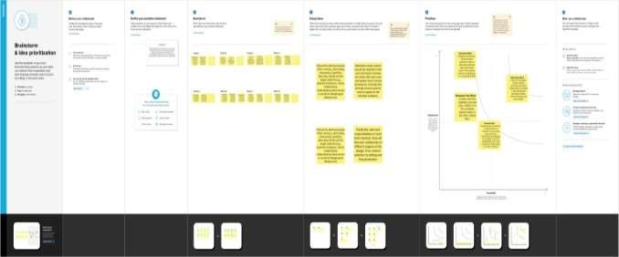

### 3.RESULT

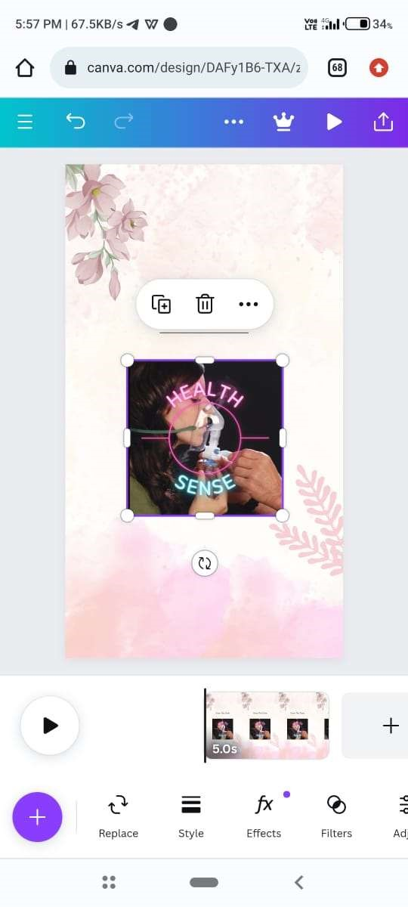

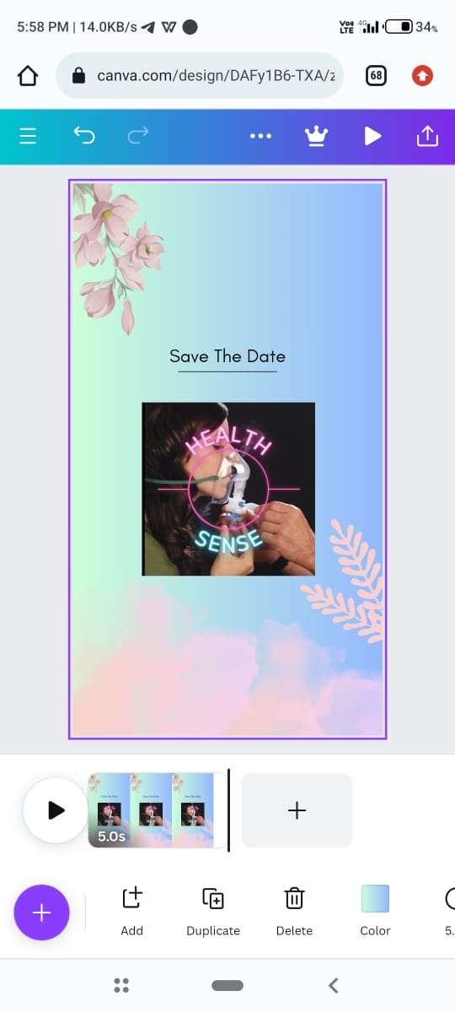

t

Indian

FestJ

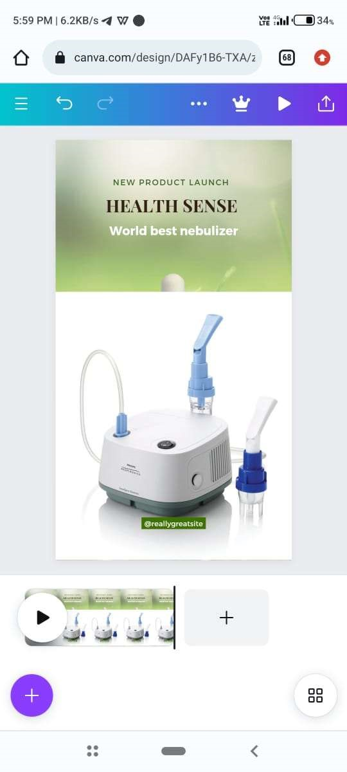

## 4. ADVANTAGES AND DISADVANTAGES

### Advantages

✓✓ Batching multiple Reels covers at once to save you time, in the long run.

✓✓ Accessing your branding to create a cohesive look across your covers.

✓✓ Designing eye-catching covers using all of Canva's visual

elements and features.

✓✓ Using Canva templates to save you even more aren't starting from scratch.

### Disadvantages

✓✓ Canva Style.

✓✓ Limitation on the Number of Templates.

✓✓ Alignment Concerns.

✓✓ Export Settings are Limited.

✓✓ Cannot Download the “Raw” File to Your Computer.

✓✓ The Free Version is Limited.

✓✓ You are Unable to Move One Design to Another

Design.

✓✓ Intellectual Property Belongs to Canva.

## 5. APPLICATIONS

 KineMaster

 Filmora

 Splice

 Clips app

 YouCut

 iMovie

 GoPro Qui

## 6. CONCLUSION

The quick verdict. Canva is an excellent design app and arguably one

of the most useful tools a small business can have in its arsenal. It lets you create an astonishingly large range of assets including adverts, infographics, videos and even websites easily, cheaply and quickly